1. 打开APPS中的Camera Calibrator
2. 单击Add Images导入要标定的图片（图片横纵比要相同）（不知道什么原因九张图片有三张不能导入）

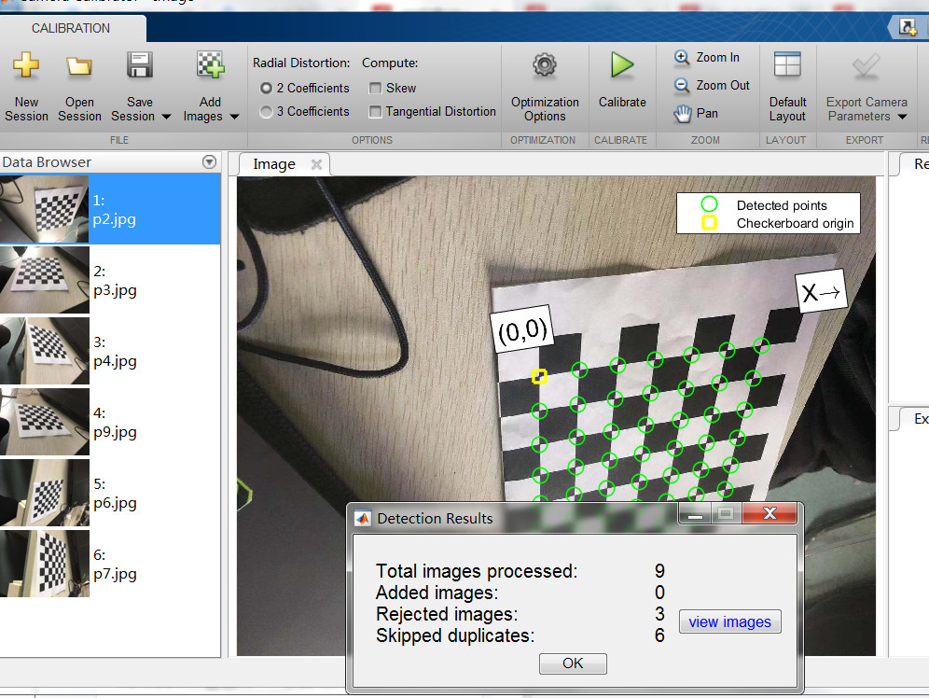

1. 单击Calibrate进行标定

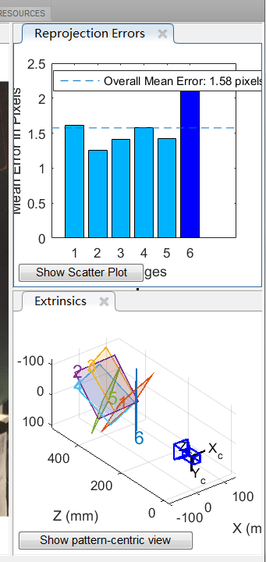

1. 单击Export Camera Parameters导出相机标定参数，在matlab工作空间里可以看到相机参数的属性，如下所示

cameraParams =

cameraParameters with properties:

Camera Intrinsics

IntrinsicMatrix: [3x3 double]

FocalLength: [1.2488e+03 1.2342e+03]

PrincipalPoint: [682.9901 536.4851]

Skew: 0

Lens Distortion

RadialDistortion: [0.2892 -0.9016]

TangentialDistortion: [0 0]

Camera Extrinsics

RotationMatrices: [3x3x6 double]

TranslationVectors: [6x3 double]

Accuracy of Estimation

MeanReprojectionError: 1.5753

ReprojectionErrors: [49x2x6 double]

ReprojectedPoints: [49x2x6 double]

Calibration Settings

NumPatterns: 6

WorldPoints: [49x2 double]

WorldUnits: 'mm'

EstimateSkew: 0

NumRadialDistortionCoefficients: 2

EstimateTangentialDistortion: 0

>>